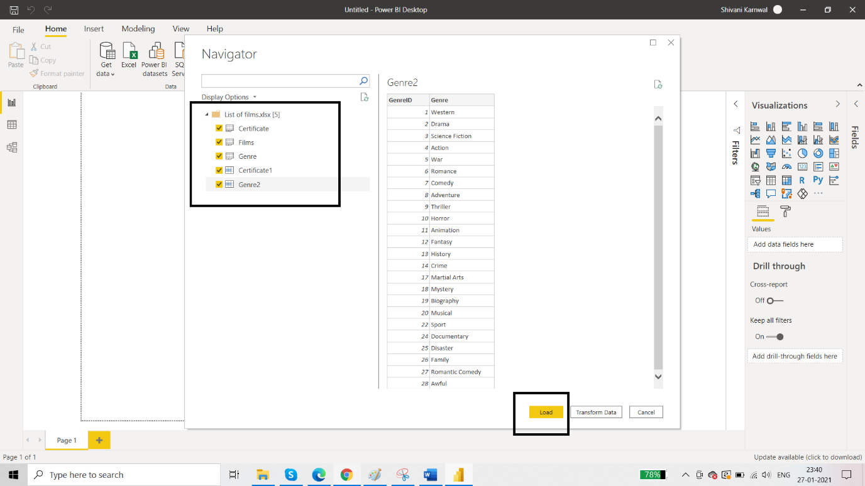

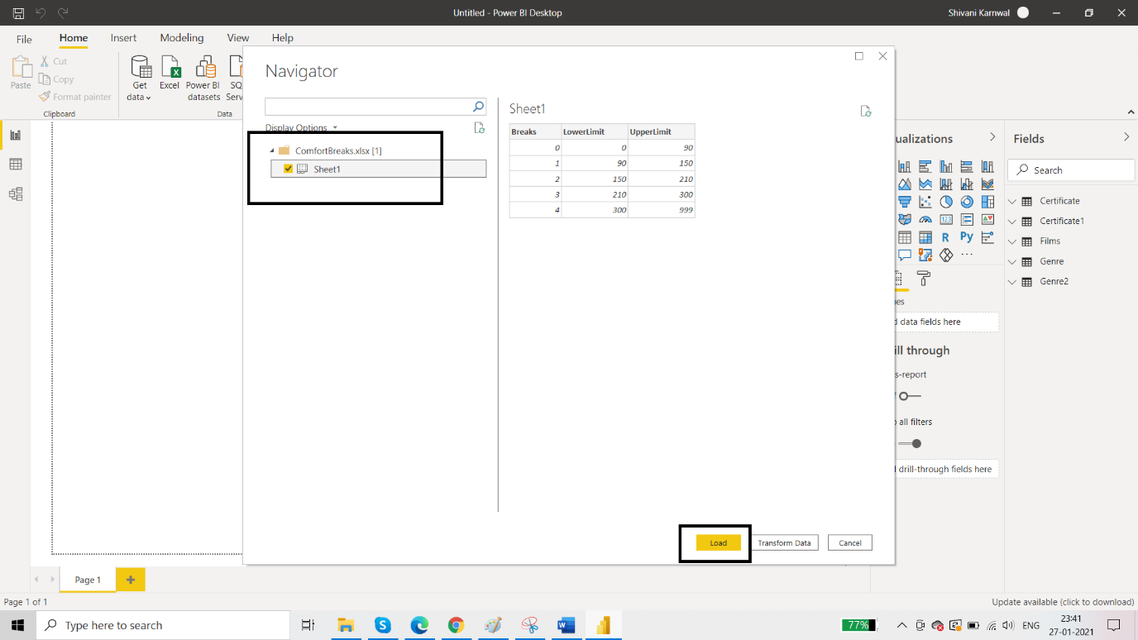

To create a new column go to Data view & click on New column in Films table . Name it as Number Breaks 1 & use this dax formula:

Number breaks 1 = CALCULATE(VALUES(Sheet1[Breaks]),Sheet1[LowerLimit]<=EARLIER(Films[RunTimeMinutes]),Sheet1[UpperLimit]>EARLIER(Films[RunTimeMinutes]))

Second apporach -

Number Breaks 2 = SWITCH(TRUE(),

Films[RunTimeMinutes]<90,0,

Films[RunTimeMinutes]<150,1,

Films[RunTimeMinutes]<210,2,

Films[RunTimeMinutes]<300,3,

